**ANGULAR CRUD USING JSON**

At the End of document you’ll be able to perform Angular CRUP operation using JSON

In order to Implement Angular CRUD application here we’re using JSON as server.

For this we need to create a JSON File based on input fields:

{

"posts": [

{

"empId": "t-shirt",

"empName": "red",

"employee_salary": "4500",

"empAge": "25"

}

]

}

Save the file as posts.json as we will be using this as server to perform CRUD operations.

To Install JSON we need to write:

npm install -g json

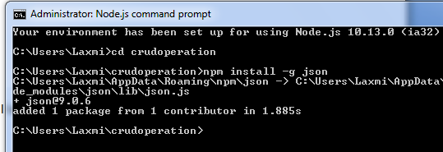

In order to start JSON we need to write:

Navigate to the folder where you have created in workspace

For Example here I have created posts.json file in app folder in workspace:

C:\Users\Laxmi\crudoperation\src\app

Now open command prompt from start and navigate to folder:

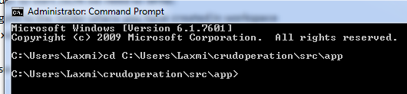

Here we need to start server:

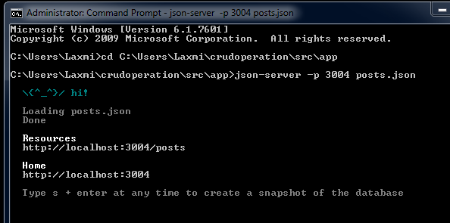

Here server is running successfully.

Now In browser type

<http://localhost:3004/>

& Enter.

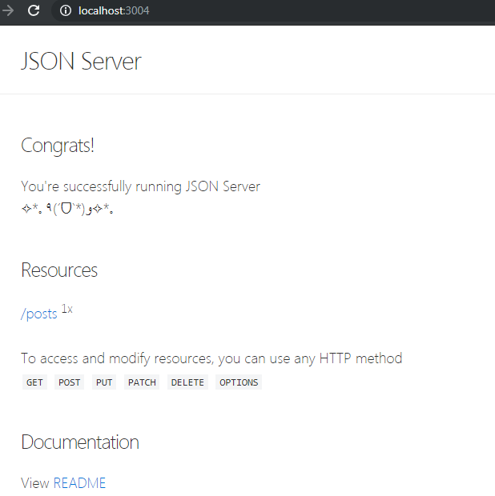

Click on Posts you’ll find the details:

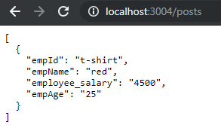

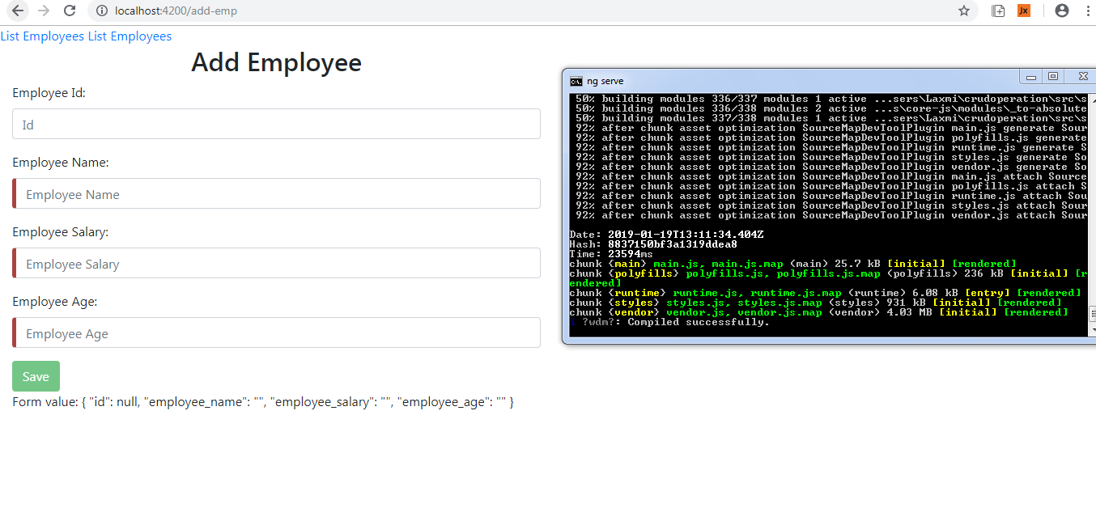

Now Perform Operations: Insert, Update, and Delete.